PhD Title: Carbon Fluxes and Fates in Flatwood Streams of North Florida
Inland waters—streams, rivers, lakes, ponds, and wetlands—are crucial to global carbon cycling, and serve as the drainage network for the terrestrial biosphere (Cole et al., 2007; Regnier et al., 2013). Despite covering only 1% of Earth’s surface (Battin et al., 2009), inland waters play a disproportionately active role in the carbon cycle (Battin et al., 2009; Cole et al., 2007). Of the 3.4 Pg-C/year delivered to streams from the terrestrial landscape (Drake et al., 2018; Raymond et al., 2016), only ~30% (0.95 Pg-C/year) returns to the oceans (Aufdenkampe et al., 2011; Kempe, 1982.; Regnier et al., 2022). The other 80% is buried in sediment, mineralized, or degassed to the atmosphere (Battin et al., 2009; Drake et al., 2018; Marx et al., 2017; Regnier et al., 2022). The global carbon cycle and the hydrologic cycle are intrinsically coupled (Abril & Borges, 2019; Battin et al., 2023; Zarnetske et al., 2018); the carbon discharged to oceans is the byproduct aquatic biogeochemical transformations and losses as water transitions from the terrestrial uplands to coastal marshes (Battin et al., 2009; Cole et al., 2007).
Streams are “active pipes” that “plumb” the terrestrial landscape by transporting, storing, and transforming terrestrial litterfall and debris (Cole et al., 2007). Estimated stream CO2 emissions are equal to terrestrial net ecosystem productivity (Drake et al., 2018), yet less than half of terrestrial inputs are delivered to oceans (Aufdenkampe et al., 2011; Kempe, n.d.; Raymond et al., 2013; Regnier et al., 2022). Of the aforementioned 3.4 Pg-C/year exported from the terrestrial landscapes, (hypothesized) 0.6 Pg-C/year is buried in sediment (Battin et al., 2009), 0.3 Pg-C/year is mineralized (Regnier et al., 2013), and 0.95 Pg-C/year is transported to oceans (Regnier et al., 2013), leaving a significant 1.5 Pg-C/year gap (Kirk & Cohen, 2023). This imbalance presents major uncertainties with the global carbon budget, especially when parsing stream carbon sources and gas fluxes.
Wetlands, in contrast, are functionally unique inland waters, serving as global carbon sinks rather than carbon sources (Abril & Borges, 2019; Cole et al., 2007). Wetland emergent vegetation both sequesters CO₂ and produces organic matter (OM) (Abril & Borges, 2019; Wilcock et al., 1999) while hydric soils bury carbon for long residence times (Mitsch et al., 2013; Raymond et al., 2013). Although wetlands contribute to atmospheric GHG, wetland productivity and carbon burial offset emissions (Mitsch et al., 2013; Vidon et al., 2010). In addition to serving as significant carbon sinks, due to the saturated conditions, wetlands are global hotspots that transform carbon, as well as store, before exporting it downstream (Hedin et al., 1998; Marton et al., 2015; Vidon et al., 2010),
Streams and wetlands are intricately linked: wetlands can serve as stream headwaters, streams facilitate longitudinal export between wetlands, and the surficial aquifer (SAq) is the intermediary supporting lateral connectivity (Abril & Borges, 2019; Evenson et al., 2018; McLaughlin et al., 2014). Streams, wetlands, and the surficial aquifer (SAq) together form the “wetlandscape,” influencing the biogeochemical fingerprint of a watershed and affecting the degree of carbon storage and export (Evenson et al., 2018; McLaughlin et al., 2014; Zarnetske et al., 2018). The SAq facilitates watershed connectivity, and inundation supports carbon storage (Evenson et al., 2018; McLaughlin et al., 2014; Zarnetske et al., 2018), yet few studies have systematically explored how the bidirectional exchange of carbon between inland waters- specifically wetland, riparian, and stream boundaries- shape the local and global carbon cycles. Current estimates of carbon mass transfer separate the aquatic from the terrestrial, and as a result, wetlands- intermediaries between terrestrial and aquatic systems- are challenging to distinguish remotely and are often excluded from carbon budgets (Cole et al., 2007; Drake et al., 2018), inadvertently omitting a significant sink and source of carbon. Similarly, small headwater streams are often located in canopy-covered, distant areas, making them difficult to delineate both remotely and in the field (Drake et al., 2018; Marx et al., 2017). Yet, small streams, 3 orders and lower, source 36% of stream emissions (Marx et al., 2017). Difficulties associated with delineating the extent of inland waters, and the unknowns related to inland water processing, create keystone discrepancies. The “CO2 gap”, broadly assumed to be groundwater seepage (Hotchkiss et al., 2015; Siemens & Villarreal, 2003), is massively provisional without first mapping the wetlandscape and its temporal and spatial influences (Kirk & Cohen, 2023).
The necessity for carbon budgeting and transfer models is to identify and quantify the significant players and key exchanges within the global carbon cycle (Cole et al., 2007). Improving our understanding of carbon sources and sinks, and how aquatic pathways link these elements, can enhance carbon flux estimates, provide insights for climate change mitigation, improve CO₂ management, and aid in predicting feedback loops (Battin et al., 2023; Cole et al., 2007). Resolving discrepancies in the global carbon budget is challenging, but detailed observational studies across diverse landscapes are crucial for addressing these ambiguities (Battin et al., 2023). For my PhD dissertation, I will observe a low relief “wetlandscape” of North Florida. Through high-frequency datasets and water sampling, I aim to observe the temporal and spatial dynamics of stream carbon, investigate stream carbon sources, and explore how landscape hydrology influences stream carbon.
- Chapter 1: Observe the temporal and spatial dynamics of carbon within low-order, flatwood streams.
- Chapter 2: Investigate the influence of the river corridor (RC) on stream carbon.
- Chapter 3: Holistically map flatwood stream carbon sources and fluxes.
My intention for this research is to emphasize the importance of aquatic-terrestrial ecotones while displaying the influence of landscape hydrology on regional, and in turn, global carbon cycling. Practically, this work will inform management decisions on how to optimize carbon storage on the watershed-level scale, ideally aiding in carbon-credit programs.

Chapter 1: Temporal and spatial carbon dynamics in Flatwood, Blackwater Streams: the Chimney-Reactor Pendulum
Streams link terrestrial and marine environments, transporting, storing, and transforming terrestrial carbon before it reaches the world’s oceans (Battin et al., 2009; Cole & Caraco, 2001; Regnier et al., 2022). Terrestrial litterfall and debris enter small, low-order streams and accumulate in large, high-order rivers before discharging into coastal marshes. In the outdated, “conventional carbon cycle”, this transport from low to high-order streams was viewed as passive (Battin et al., 2009), with minimal biogeochemical activity (Cole et al., 2007). Now, streams and rivers are understood to play an active role in global carbon cycling. Less than half of terrestrial carbon inputs reach the oceans; the rest is mineralized or stored as water flows toward the coast (Aufdenkampe et al., 2011; Kempe, n.d.; Raymond et al., 2013; Regnier et al., 2022). Yet, CO2 emissions from global streams are equivalent to terrestrial net ecosystem productivity, and total stream carbon is often greater per unit area than the surrounding terrestrial landscape (Drake et al., 2018). Lotic carbon outputs are greater than inputs, creating uncertainties in regional and global carbon budgets. The “carbon gap” is debated in the literature but largely attributed to CO2-rich groundwater degassing from the stream channel (Hall et al., 2016, Siemens & Villarreal 2003). However, other sources, such as wetland or internal production, are insufficiently explored and constrained (Abril & Borges, 2019; Bertuzzo et al., 2022; Kirk & Cohen, 2023).
An inadequately researched but increasingly important area of stream carbon cycling is the contribution of low-order, headwater streams. Small streams, though covering less than 1% of Earth's area (Battin et al., 2009), constitute the largest portion of all lotic ecosystems and drain approximately 75% of all watersheds (Marx et al., 2017). Headwater catchments have higher DOC concentrations than high-order, downstream waters (Ågren et al., 2007; Ledesma et al., 2015), and 36% of stream CO2 emissions is predicted to originate from small streams (0.93 Pg-C/yr) (Marx et al., 2017). However, estimates of small stream carbon fluxes, and the processes driving the high biogeochemical activity are relatively few and largely speculative (Drake et al., 2018; Marx et al., 2017). Current research largely investigates carbon dynamics in stream orders four or higher, overlooking first, second, and third order, often perennial, streams (Cole et al., 2007; Drake et al., 2018; Lauerwald et al., 2012). Numerous models have predicted a negative relationship between gas transfer velocity and stream order (Marx et al., 2017; Raymond et al., 2013), estimating CO2 emissions from first to third-order streams contribute three times the global stream average, suggesting that global budgets underestimate global stream emissions (Raymond et al., 2013). This knowledge gap is partially due to the location of small, headwater streams, which are typically in remote, undeveloped areas, making remote sensing delineation challenging and field access energy-intensive (Battin et al., 2023; Marx et al., 2017; Raymond et al., 2013). Additionally, scaling limitations, especially for gas exchange rates and discharge estimates, in “infinitely small” perennial streams, create inaccuracies that hinder comprehensive global estimates (Battin et al., 2009; Lauerwald et al., 2012; Marx et al., 2017).
What is understood, but nonetheless poorly constrained, is that stream carbon is sourced from two pathways: the chimney or reactor pathway (Bernal et al., 2022; Hotchkiss et al., 2015; Lupon et al., 2019). The chimney pathway is the passive transport of externally sourced carbon (predominantly from soil, groundwater, or the riparian zone) that degasses from streams with minimal downstream transport (Duvert et al., 2019). In this pathway, the stream serves as a “chimney,” or a vector for atmospheric exchange. In contrast, the reactor pathway involves the mineralization of organic carbon through respiration or anaerobic processes, producing CO2 as a byproduct (Cole & Caraco, 2001). In the reactor pathway, carbon is actively transformed from organic to inorganic forms. As mentioned, more CO₂ is degassed from streams than the sum of terrestrial inputs and internal production (the reactor pathway) can account for (Kirk & Cohen, 2023). This “gap” is attributed to “chimney” carbon (Hall et al., 2016; Siemens & Villarreal, 2003). However, the reactor pathway, the internal production of carbon via mineralization, is itself poorly constrained (Drake et al., 2018), with publications attributing anywhere from 12% to 40% of total stream carbon to respiration (Abril et al., 2014; Bertuzzo et al., 2022). Furthermore, current estimates do not incorporate temporal or spatial changes that could impact stream carbon sources. Seasonality affects temperature and precipitation, which in turn influences biogeochemical reaction rates and flow regimes, impacting residence times and affecting stream potential to process carbon (Liu et al., 2022; Zarnetske et al., 2018). Additionally, landscape slope, soil permeability, and wetland area impact lateral, overland, and subsurface carbon export, modulating the influence of the reactor pathway and increasing “chimney carbon”. Streams “swing” between chimney and reactor states, dictated by temporal and spatial fluctuations in the landscape hydrology (Zarnetske et al., 2018). Although the chimney pathway may dominate in some streams, it does not apply to all flowing waters year-round. The same stream may exhibit a more prominent reactor pathway when flow is equal to processing time (low residence times) (Bernhardt et al., 2017; Hall et al., 2016; Zarnetske et al., 2018), while receiving chimney carbon during periods of high discharge. Ignoring spatial and temporal lotic dynamics undermines the concept of “active pipes”—streams as active, reactive components in global carbon cycling.
For my first chapter, I will investigate the temporal and spatial dynamics of carbon within low-order, flatwood streams over multi-annual time scales, focusing on the response to flow extremes, seasonal fluctuations, and the surrounding landscape. To explore these dynamics, I have selected nine remote, flatwood streams within the Bradford Experimental Forest (BEF) to deploy high-frequency, long-term sensor packages containing CO₂, dissolved oxygen (DO), and methane sensors. In addition to high-frequency observations, I will collect monthly samples for dissolved organic carbon (DOC), fluorescent dissolved organic matter (FDOM), dissolved inorganic carbon (DIC), and particulate organic carbon (POC). I aim to parse stream-carbon fluxes into the reactor and chimney pathways, a perspective rarely explored in current literature. I hypothesize:
- The chimney pathway dominates in flatwood streams, but the reactor pathway becomes more prominent during baseflow conditions when residence times are longer and external contributions are minimal.
- I also expect streams in basins with greater wetland area to have more influential chimney pathways, whereas streams in basins with less wetland area exhibit a more prominent reactor pathway.
- Lastly, I expect DIC is the dominant stream carbon species across flow regimes but DOC and POC will increase with increasing discharge.
My objective for this chapter is to provide greater insight into headwater, low-order stream contributions to regional and global carbon cycling and to demonstrate how landscape hydrology can influence stream carbon dynamics.
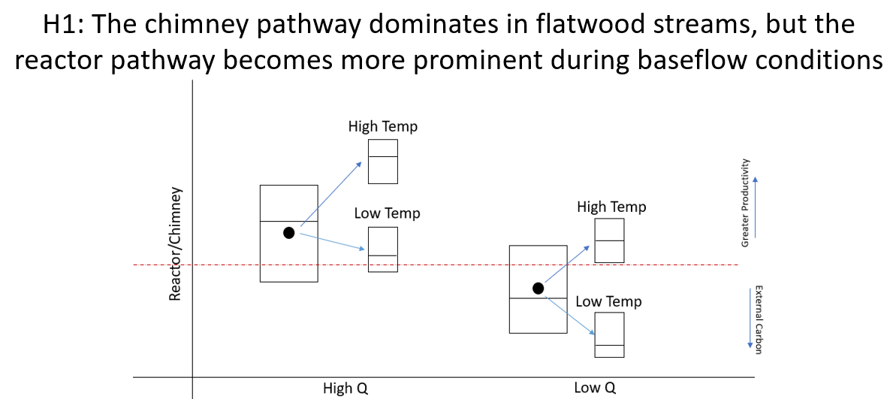
Figure 1: Conceptual visualization of how streams “swing” between chimney (CO₂ passively degassed from the stream channel) and reactor (internally produced CO₂) pathways depending on flow regime and seasonality. I hypothesize the reactor pathway will be more prominent during low discharge and high temperature when reactions rates mirror residence times.
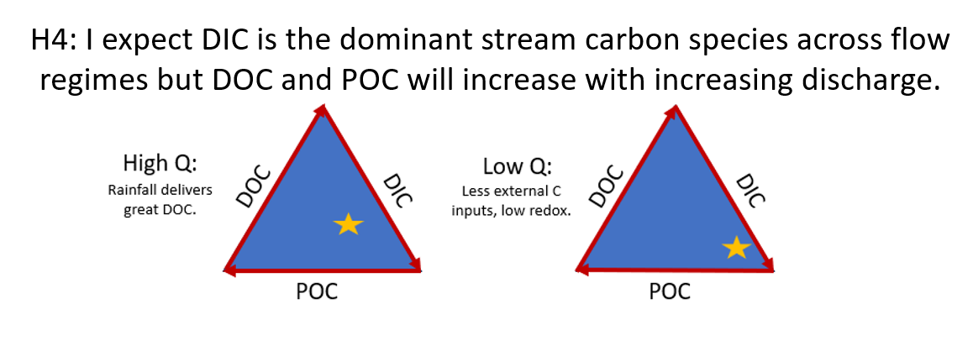
Figure 2: A conceptual diagram illustrating the proportions of carbon species within BEF blackwater streams. I predict CO2 will be the most concentrated carbon species, resulting in DIC comprising the largest proportion of stream carbon. However, during high discharge periods, I expect DOC and POC concentrations to increase, potentially shifting the carbon dynamics to be more proportionally equal.
Methods:
Sites:
The BEF is a contiguous pine flatwoods landscape situated above the Hawthorne Formation clay bed, which confines the principal aquifer, the Upper Floridan Aquifer (UFA) (Hensley & Cohen, 2017). This area, characterized by low-relief topography, features numerous depressional-basin wetlands typical of North Florida flatwoods. These wetlands, both isolated and riparian, support a shallow surficial aquifer that acts as a transport network for nutrients. The land is primarily managed for silviculture and is largely owned by the Rayonier Corporation, with only a few residential homes and businesses present.
Streams within the BEF exhibit typical characteristics of blackwater systems: they are tannic, rich in dissolved organic carbon (DOC), have low pH levels, and contain high concentrations of carbon dioxide (CO₂) (~20,000 ppm). These streams, both permanent and intermittent, drain the landscape before discharging into the Sampson River (at the southern extent) or Sampson Lake (at the northern extent). Nine streams (Stream IDs: 3, 5, 5a, 6, 6a, 7, 9, 13, and 15) across nine delineated basins were chosen for long-term observations and monthly sampling. Each stream displays distinct characteristics owing to each basin’s specific features (FIGURE 3), such as wetland area and groundwater influence.
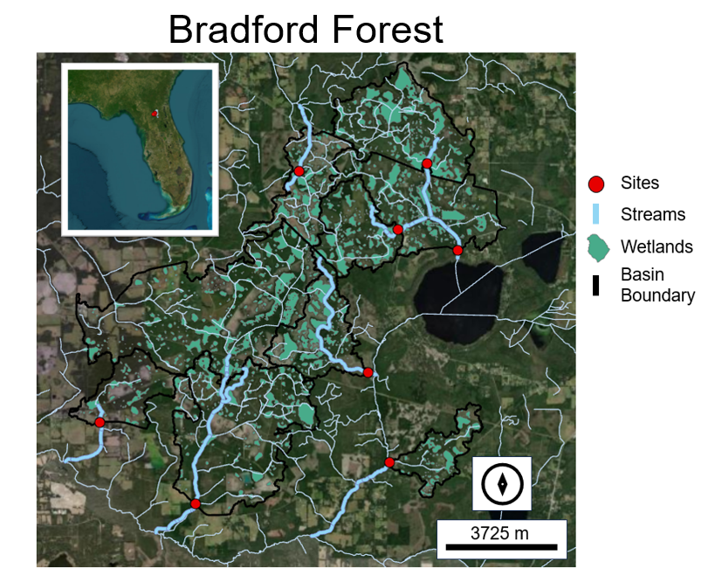
Figure 3: Map of Bradford Experimental Forest (BEF) highlighting its inland waters. Red points indicate stream sampling locations, thinner blue lines represent the stream network, thicker blue lines show the sites, black lines delineate the basin boundaries, and green shapes mark wetland depressions. BEF has a low relief landscape, dotted with depression wetlands and drained by blackwater streams.
Long-term, high-frequency observations:
Each stream will be equipped with a sensor package that tracks hourly changes in water quality. This package includes sensors for dissolved oxygen (DO) (Onset HOBO U26-001, Onset Computer Corporation, Massachusetts, USA), pH (Onset HOBO MX2501), CO₂ (Eosense eosGP, Eosense Inc., Dartmouth, NS), and specific conductivity (SpC) (Onset HOBO U24-001), as well as a pressure transducer (PT) (Onset HOBO U20-001-04), to measure depth. In streams 5 and 6a, located in the northern and southern regions respectively, a PT will be deployed in ambient air for accurate water depth calculations. DO, temperature and depth readings will be used to estimate stream metabolism (see below). Temperature, CO₂, and pH will be used to interpolate continuous concentrations of HCO₃ ⁻and CO₃²⁻ from Bjerrum equations (see below). Each sensor package will be serviced, and data offloaded once a month.
Monthly Sampling:
By sampling for each carbon species, I will estimate total stream carbon and observe how the proportions of these species change with flow and season. Particulate organic carbon (POC) remains largely unexplored due to the nature of POC fluxes, which are storm-driven and therefore challenging to capture (Marx et al., 2017). However, in these low order, blackwater systems, notable POC concentrations are expected. Dissolved organic carbon (DOC) is derived from the weathering of POC and powers respiration. DOC has the potential to alter energy dynamics within lotic ecosystems, serving as the preferred electron acceptor in aerobic and anaerobic biogeochemical reactions (Zarnetske et al., 2018). Furthermore, DOC concentrations have been linked to flow, with high discharge rates positively correlated with DOC concentrations (Marx et al., 2017). Dissolved inorganic carbon (DIC) includes mineral carbon and CO₂. On average, the pH of BEF streams is less than 5, so substantial concentrations of DIC are not expected. Nonetheless, given that Florida is essentially a massive limestone deposit, it is necessary to measure DIC. Fluorescent dissolved organic matter (FDOM) will be used to extrapolate carbon quality and assess differences in quality across seasons, and between the Sampson River and its headwater streams.
Analyzing DIC is notoriously challenging due to its tendency to degas from the sample causing concentrations to be underestimated. To minimize error, acid-washed Shimadzu sample vials are used in the field to sample DIC, avoiding any potential degassing during decanting. In the field, vials are filled to maximum capacity to prevent head-space equilibration. After collection, all samples are stored in the fridge and analyzed within 48 hours.
Both DIC and DOC analyses will be conducted using the Shimadzu TOC-L analyzer, employing the total organic carbon (TOC) measurement method. Although FDOM is more stable than DIC, it can degrade after extended periods in storage, or denatured if frozen. Therefore, FDOM samples are stored in the fridge in opaque, dark bottles and analyzed on the Horiba Aqualog within three weeks of collection. POC samples are collected using 500mL to 1L Nalgene bottles, submerged midway in the water column and capped underwater. The samples are then filtered using 0.45-micron filters. These filters are then processed utilizing the ash-free dry weight method.
Stream Metabolism:
To estimate the significance of the reactor pathway in flatwood streams, stream metabolism—the rates of gross primary productivity (GPP) and ecosystem respiration (ER)—will be modeled. Stream metabolism serves as a holistic, in-situ measure of stream carbon cycling and organic carbon mineralization. ER represents the total respiration (oxygen consumption) and is the dominant pathway for internal CO₂ generation, while GPP represents the total productivity (photosynthesis; oxygen production) within the ecosystem. One-station stream metabolism methods estimates GPP and ER by tracking continuous fluctuations in dissolved oxygen (DO) concentrations (mg/L) over time (hr^-1) and depth (m^-3), calculating an oxygen flux (g O₂ m⁻² hr⁻¹). Assuming the respiration ratio is 1:1 for CO₂ and DO (where every mole of DO consumed results in one mole of CO₂), the difference between observed CO₂, and CO₂ estimated by ER, is allochthonous CO₂ from the chimney pathway. Stream metabolism modeling will be performed using StreamMetabolizer (Appling et al. 2020), an open-source R package that integrates principles from Odum’s Primary Production in Flowing Waters and Bayesian modeling to estimate GPP and ER.
Estimating Gas Exchange
To determine air-water gas exchange rates—an essential parameter for stream metabolism modeling—the reaeration coefficient (K600) will be field-estimated using gas dome methods. During each monthly field visit, K600 will be empirically estimated using a floating dome, an inverted plastic container with a headspace volume of 15.5 L. Within the dome, a high-frequency CO2 sensor will be placed in the headspace, sampling at 1 sample per 10 seconds for approximately 25 minutes. Given that stream CO2 concentrations often exceed 20,000 ppm, the diffusion of CO2 from the water column to the headspace will be monitored to calculate the rate of air-water equilibration. The gas exchange velocity, K (m d⁻¹), which represents diffusion between the water column and atmosphere (Hall & Ulseth, 2020), and subsequently the reaeration coefficient, k (d⁻¹) (calculated as K divided by stream depth), were predicted following methodologies outlined by Khadka et al., 2014 and McDowell & Johnson, 2018.
Using the field-measured K600 values and discharge data, a rating curve will be developed to enable continuous estimation of K600. This rating curve will be integrated into StreamMetabolizer to refine K600 estimates as a function of discharge to improve accuracy. Discharge measurements will be obtained through periodic dilution gauging. During monthly field visits, streams with observable flow will undergo dilution gauging using salt dilution techniques and slug-injection methods. By correlating depth at the time of dilution gauging with discharge rates, a rating curve will be constructed to maintain continuous discharge estimates.
DIC Interpolation:
Using the Bjerrum equation, continuous bicarbonate (HCO₃⁻) concentrations will be interpolated from temperature, pressure (PT), pH, and CO₂ sensor measurements. The R package seacarb facilitates estimation of the first and second dissociation constants of carbonic acid based on temperature and water pressure, streamlining data manipulation.
Preliminary Results:
DO and sensors were deployed in June 2023, with CO₂ sensors installed in November 2023. Our sensor package recorded a distinct wet period (Winter 2023) and a dry period (Summer 2024). Overall, the chimney pathway is the dominant CO₂ source across sites and flow regimes (Figure 4). However, at sites 5, 9, and 7, chimney and reactor trends intersect, indicating periods where internal carbon production is roughly equal to passive, chimney CO₂. Aligning with my hypothesis, the reactor pathway is negatively correlated with increasing discharge while the chimney pathway is positively correlated. However, the trends among the sites are dissimilar indicating landscape hydrology may influence the reactor-chimney response.
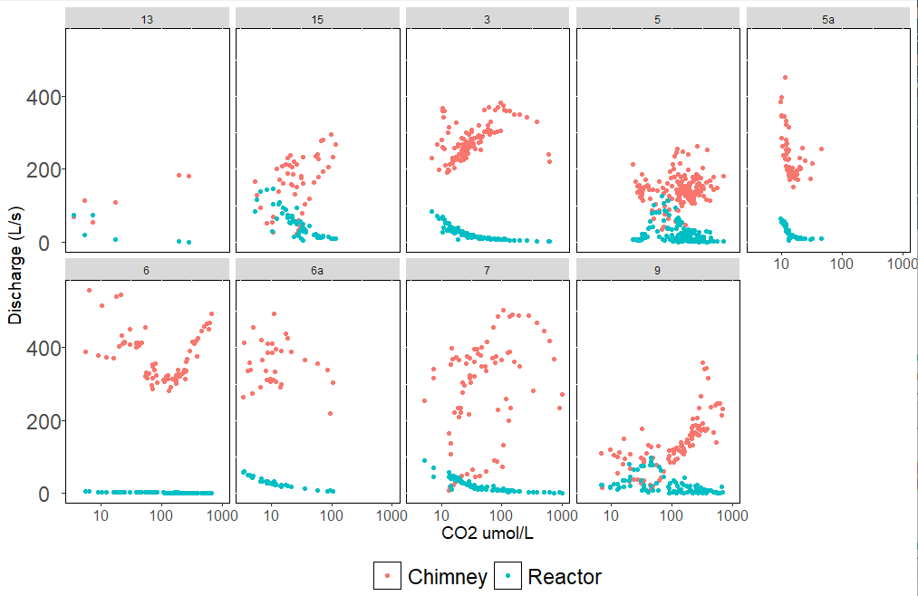
Figure 4: Depicts the relationship between “reactor carbon” (internally produced CO₂) and “chimney carbon” (externally sourced CO₂) with discharge. As expected, the chimney and reactor pathway response to flow regime is contrary with the reactor pathway having a negative response and the chimney pathway having a positive response.
Water sampling for DIC, DOC, and POC began in April 2024. Therefore, too few data points are available for ternary diagrams of carbon species; boxplots are used instead. With our current sampling size, it seems all carbon species have a positive relationship with discharge (Figure 5). The exception is site 7, which may have a source-limited concentration-discharge dynamic (Aho et al., 2021). Contrary to my hypothesis, DIC and DOC are comparable in these blackwater streams. However, the majority of stream samples were taken during a dry period, potentially skewing stream carbon dynamics and species composition.
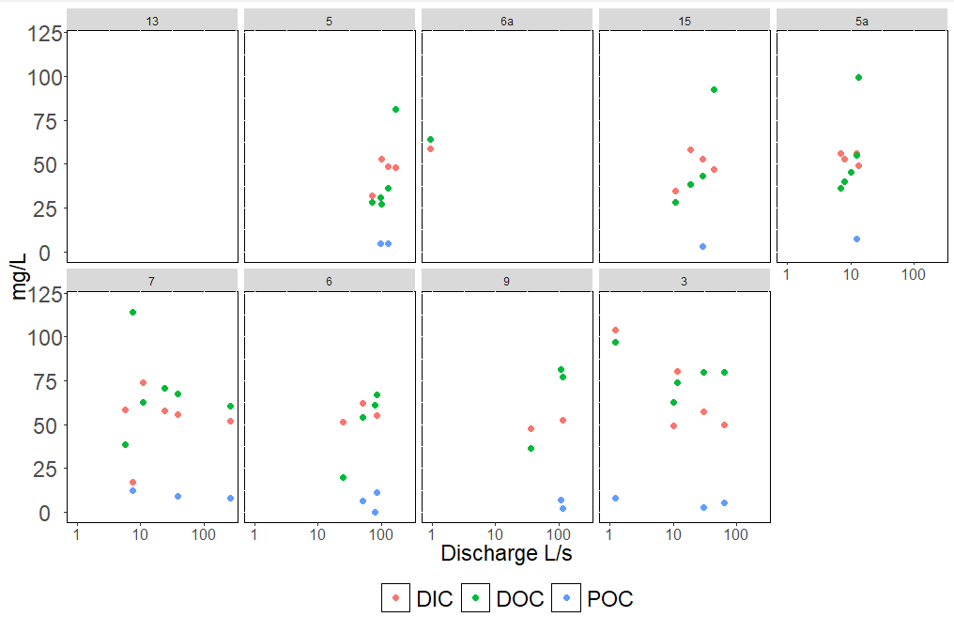
Figure 5: Displays current trend between stream carbon species and discharge. The sampling pool is too small to draw conclusions, however, POC, DOC, and DIC have a positive trend with increasing discharge.
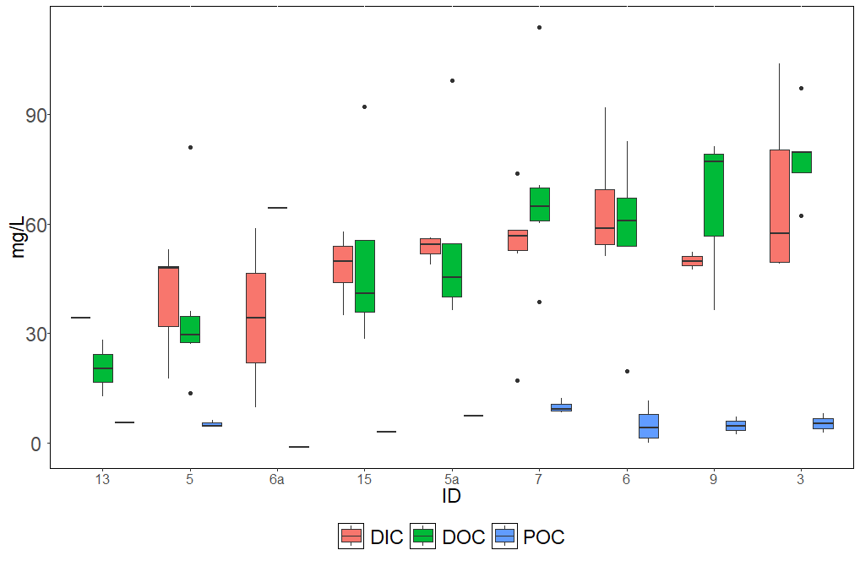
Figure 6: Depicts the spread of carbon species among sites. Contrary to my hypothesis, DIC and DOC have comparable concentration with DOC even being more concentrated in select streams (5a and 5). However, majority of water samples were taken during a dry period and may display a skewed relationship between stream carbon dynamics and discharge.

Chapter 2: The River Corridor is a Significant Source of Stream Carbon.
Wetlands are functionally unique inland waters, serving as global carbon sinks rather than carbon sources (Abril et al., 2014; Cole et al., 2007; Raymond et al., 2013). Wetland emergent vegetation is highly productive, sequestering and mineralizing CO₂ while wetland soils—hydric and anoxic from the surficial aquifer—store litterfall, debris, and decaying organic matter (OM) for months to decades (Abril & Borges, 2019; Cole et al., 2007; Mitsch et al., 2013; Raymond et al., 2013; Wilcock et al., 1999). The long residence times allow substantial carbon processing (Leibowitz et al., 2018a; Mitsch et al., 2013), with most wetland carbon fated for long-term burial and a minority being mineralized by anaerobic processes or exported downstream (Cole et al., 2007; Raymond et al., 2013; Solano et al., 2024). While wetland hydric soils are recorded to be substantial sources of greenhouse gases (GHGs), the carbon storage potential of wetlands (Leibowitz et al., 2018a), coupled with the productivity of emergent vegetation, offsets these emissions. Often described as the intermediate between the terrestrial and the aquatic (Cole et al., 2007), wetlands possess the productivity of the terrestrial biosphere while maintaining inundated conditions of aquatic sediments.
Many wetlands have strong connectivity with streams, rivers, and lakes via subsurface or overland flow (Leibowitz et al., 2018a; Raymond et al., 2013; Solano et al., 2024). Specifically, riparian wetlands bridge lotic and terrestrial environments, serving as the ecotone between terrestrial uplands and flowing waters (Kirk & Cohen, 2023; Ledesma et al., 2018). Unlike depression wetlands, all lateral exports from the catchment must bypass riparian wetlands before discharging to streams. Therefore, despite comprising only 7% of wetland area, riparian wetlands are hypothesized to have a disproportionate influence on the global carbon budget (Abril & Borges, 2019; Kirk & Cohen, 2023). Coined by Abril and Borge (2019) as “carbon pumps,” riparian wetlands possess significant potential for carbon storage and delivery, with riparian groundwater, soil water, and hyphoreic zone having higher DOC (Ledesma et al., 2015, 2018) and CO₂ (Abril et al., 2014) concentrations than stream water. At current export rates, riparian wetlands are predicted to be an inexhaustible carbon source (Ledesma et al., 2015). Beyond storage, riparian wetlands are carbon reactors, transforming carbon in their hydric soils (Abril et al., 2014; Mitsch et al., 2013) and facilitating carbon exchange between the stream, the hyporheic zone, and the uplands (Abril & Borges, 2019; Kirk & Cohen, 2023; Ledesma et al., 2018).
The bidirectional exchange between a stream and its riparian wetland is termed the river corridor- stream, the hyporheic zone, and the riparian wetland from surficial aquifer to canopy (Harvey & Gooseff, 2015; Kirk & Cohen, 2023). Encompassing both the riparian wetlands and stream respiration, the river corridor is assumed to play a prominent role in stream carbon cycling (Abril & Borges, 2019; Kirk & Cohen, 2023; Ledesma et al., 2015, 2018). Yet, the contribution of the river corridor to the global carbon budget is largely unknown, poorly constrained, and often neglected in research. The river corridor is often excluded from global estimates because remotely distinguishing riparian wetlands from terrestrial uplands is challenging, making river corridor delineations subjective (Raymond et al., 2013). Regionally, in-situ measurements of river corridor groundwater and stream CO2 dynamics are scarce. Studies investigating wetland carbon fluxes to streams often overlook riparian wetlands, instead focusing on isolated or intermittently connected wetlands (Casson et al., 2019; Hosen et al., 2018; Solano et al., 2024). Research on the riparian corridor has yet to compare riparian versus upland carbon, systematically capture carbon fluxes across terrestrial-wetland and wetland-stream boundaries or consider the landscape hydrology. In-situ measurements of riparian groundwater and stream CO₂ dynamics are scarce, leading to inflated global estimates of groundwater inputs to stream carbon while underestimating the significance of aquatic ecotones as potential global hotspots for carbon storage and exports. Kirk and Cohen (2023) found that 86% of CO₂ in the lower Santa Fe River originated from its riparian wetlands, with only 14% sourced from groundwater seepage. Similarly, studies in boreal forests have shown that up to 90% of CO₂ is derived from the river corridor (Ledesma et al., 2015, 2018).
For the second chapter of my dissertation, I will investigate the importance of the river corridor (RC) on stream carbon by estimating RC carbon fluxes to streams. In three streams, spanning a gradient of wetland coverage, I will estimate DIC, DOC, and CO₂ fluxes from the RC to the stream using a combination of water samples and sensor readings. I hypothesize:
- The RC delivers most of stream carbon and serves as a significant carbon stock in the flatwood landscape.
- RCs within basins with greater wetland area will exhibit greater carbon-storage potential due to their raised water tables supporting lateral, subsurface transport.
- Additionally, I expect RC carbon fluxes will be greatest during high discharge periods when the surficial aquifer is shallowest.
This chapter will develop a conceptual understanding of RC carbon contributions across different watershed types (confined and unconfined aquifer units) to broadly interrogate the significance of terrestrial-aquatic ecotones and lateral carbon transport.
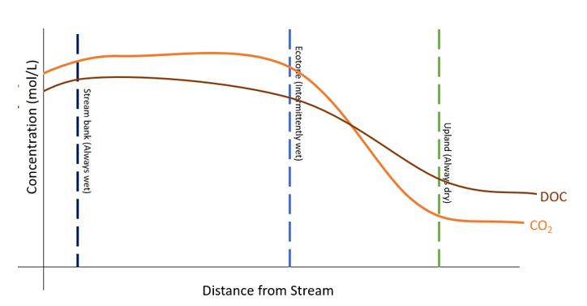
Figure 7: A conceptual visualization carbon storage across the river corridor (RC) elevation. I predict the RC will have significantly higher carbon concentrations than the adjacent uplands with carbon storage increasing with inundation. As a result, the RC is the dominant carbon source for streams.

Methods:
An ecosystem garnering increasing interest for its capacity to store carbon is the flatwoods of North Florida. Due to the flatwoods confined aquifer and dense wetland-area, deep groundwater seepage is negligible, and the flux of carbon to streams is primarily driven by lateral transport via the shallow water table. As a result, North Florida’s flatwood landscapes exhibit unique modes of carbon transport that are largely disconnected from deep groundwater upwelling. This hydrology fosters carbon storage and creates a transport network through which nutrients and particulates flow laterally downhill before ultimately discharging into tannic, blackwater streams.
For this chapter, I will observe three river corridors (RCs) from three streams (Stream: 5, 6, and 9) within Bradford Experimental Forest (BEF), a contiguous pine flatwood situated above confining clay bed (Hawthorne Formation). Each of these streams belong to three distinct basins, each representing a gradient of wetland coverage.
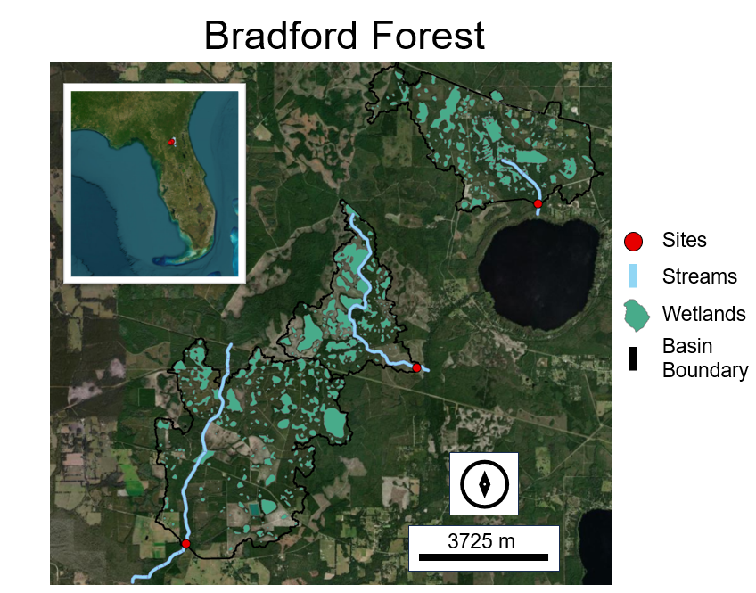
Figure 8: A map of Bradford Experimental Forest (BEF) highlighting basins 5 (most south), 6 (most north), and 9 (remainder). Red points indicate stream sampling locations, thinner blue lines represent the stream network, thicker blue lines show the sites, black lines delineate the basin boundaries, and green shapes mark wetland depressions. BEF’s wetlands foster carbon storage and create a subsurface transport network, allowing nutrients and particulates to flow laterally downhill before discharging into tannic, blackwater streams.

Sampling and sensor readings:
Along with the high-frequency, long-term sensor packages from Chapter 1, groundwater wells will be strategically installed across each stream's river corridor (RC). RC wells will be deployed along the RC’s elevation gradient (stream bank, upland, and in-between) and in any significant micro-landscapes (intermittent flow paths and depressions, if present). Each well will be installed during the dry season to ensure the shallow water table can be reached even when the stream bed is dry, ensuring at least one well from each site has a viable volume of water present for sampling. Prior to sampling, at least triple the volume of the well water will be removed. If the well water is exhausted during this process, the well will be deemed dry.
Well water will be pumped directly into sample bottles for DIC and DOC analysis. For point readings, well water will be pumped into a chamber equipped with a CO₂ sensor (K30 10%), a pH sensor, and inflow and outflow openings. The well-water will enter through the inflow opening and exit through the outflow opening, ensuring a continuous flow of well-water through the chamber. Readings will be monitored until the chamber reaches equilibrium. Equilibrium measurements will be recorded.
Sample Processing:
Both DIC and DOC analyses will follow the methods outlined in Chapter 1. For quality control, DIC will also be interpolated using the pH, temperature, and CO₂ point readings, and select samples will be periodically analyzed for alkalinity.
FDOM samples will be analyzed following the protocols outlined in Chapter 1. FDOM results will infer how carbon quality changes as it travels across the river corridor.
Discharge Estimates:
The estimation of RC lateral fluxes will use methods adapted from Kirk and Cohen (2020) and will incorporate concepts from Kalbus et al. (2016) and Leopold & Maddock (1953). This approach involves first parsing stream discharge into baseflow and high discharge, the latter assumed to be surface runoff. In the second stage, Digital Elevation Models (DEMs) will be used for stream delineation analysis to estimate the upslope contributing area (UCA). The UCA represents the land area that contributes to the stream discharge. Finally, lateral discharge is interpolated by multiplying the UCA by the baseflow, referred to as qUCA. RC carbon fluxes are then calculated by dividing RC carbon concentrations by qUCA.

Chapter 3: Mapping the Carbon Cycle in “Wetlandscapes”: Isolated-Wetland Contribute Little to Stream Carbon but Support Lateral Carbon Export
Landscape hydrology predicates that hydrologic and biogeochemical changes in one region of a watershed have the potential to cascade across the entire basin (Winter, 1980). Through the lens of landscape hydrology, the watershed is viewed as a singular, system, encompassing micro-ecosystems that collectively contribute to the basin’s distinct biogeochemical and hydrologic fingerprint (Winter, 1980). However, the relevance of "landscape hydrology" is watershed specific, dependent on the basin's connectedness or how water flows and is stored between inland waters (Evenson et al., 2018; McLaughlin et al., 2014; Mitsch et al., 2013). This landscape "connectedness" is largely dependent on wetland area, namely geographically isolated wetlands (GIWs) density (Evenson et al., 2018; McLaughlin et al., 2014; Zarnetske et al., 2018). GIWs disrupt the flow of watershed runoff. Instead of flowing down elevation and being exported to streams, runoff is intercepted and held within GIWs (Evenson et al., 2018). Here, it is either released into the atmosphere, stored within the watershed, or exchanged with the local surficial aquifer (SAq). Through this wetland-aquifer exchange, GIWs modulate the SAq by sourcing and receiving groundwater, buffering flow extremes, and dictating downstream baseflow (Evenson et al., 2018; McLaughlin et al., 2014). The SAq acts as a vector for hydrologic connectivity, facilitating transport between inland waters even in the absence of overland connectivity. Thus, the chemical and hydrologic signature of a landscape results from the "wetlandscape," or the energy exchange between the SAq and inland waters.
GIWs are global hot spots; the anaerobic conditions, long residence times, and extended hydroperiods of GIWs encourage the re-mineralization and storage of carbon (Saunois et al., 2016) while simultaneously exporting processed waters downstream through groundwater or overland flow ("spill-and-fill") (Abril & Borges, 2019; Raymond et al., 2016). However, in the literature, first-hand observations estimating GIWs' contributions to stream carbon is small. Only 15-30% of total stream carbon is sourced by GIWs, with the remainder assumed from riparian wetlands (Casson et al., 2019; Solano et al., 2024; Zarnetske et al., 2018). These studies, though useful for finite carbon budgeting, undermine GIWs' role in global carbon cycling by (1) sampling from overland, intermittent flow paths while excluding subsurface transport, and (2) failing to interrogate GIWs' influence on watershed-level carbon export. As mentioned, GIWs modulate the SAq, and therefore are integral to broader energy and water dynamics (Evenson et al., 2018; Leibowitz et al., 2018b; Zarnetske et al., 2018). Wetlandscape energy exchange functions as a chain reaction: water and its contents runoff into GIWs, where they diffuse into the SAq. The SAq then exports water to riparian wetlands and streams as baseflow (Evenson et al., 2018; McLaughlin et al., 2014), transforming and storing carbon with each transition. These exchanges determine downstream water quality, surface-groundwater interactions, watershed inundation, and importantly, carbon dynamics. Current research has yet to directly investigate the cumulative impacts of landscape hydrology on carbon cycling. While the SAq is the transport network, GIWs are "capacitors” for the wetlandscape (McLaughlin et al., 2014). Even as soils dry, GIWs can sustain the SAq and its streams into the early seasons of drought. The longer the watershed remains inundated, the greater potential for carbon storage.
For the third chapter of my dissertation, I will estimate both direct and indirect carbon contributions from GIWs to streams by longitudinally sampling for DIC, DOC, and POC from three BEF streams within basins of various wetland densities. Thus far in my PhD, I will have explored stream carbon temporal dynamics and RC fluxes in fluctuating hydrologic settings. By coupling my longitudinal sampling results with my findings from Chapters 1 and 2, I can isolate the influence of isolated wetlands. Assuming RC-discharge and respiration-discharge relationships are homogeneous throughout the stream reach, I can investigate how GIWs influence stream carbon as water accumulates downstream. Research has yet to observe GIW carbon contributions, and none have included observed RC fluxes in addition to stream metabolism models. I hypothesize:
- I hypothesize that each stream will gain in carbon, increasing in DIC, DOC, and POC as water flows downstream.
- Although I expect depressional wetlands to directly contribute to the stream carbon, I hypothesize the RC will remain the dominant carbon source.
- However, during flooded conditions, I anticipate GIW contribution will be greatest due to a shallower surficial aquifer and overland flow.
- Lastly, I expect streams in watersheds with greater wetland areas to have higher total carbon (TC) concentrations across wetland, RC, and stream boundaries.
By synthesizing my results from Chapters 1 and 2 with my results from Chapter 3 I aim to holistically map stream carbon sources and fluxes, allowing me to draw detailed inferences on low-relief, “wetlandscape” carbon budgets. By testing these hypotheses and developing a carbon budget, I aspire for this chapter to offer both an improved understanding of low-relief carbon cycling and practical applications. Specifically, my objective for Chapter 3 is to inform management decisions on how to optimize landscape hydrology for carbon storage.
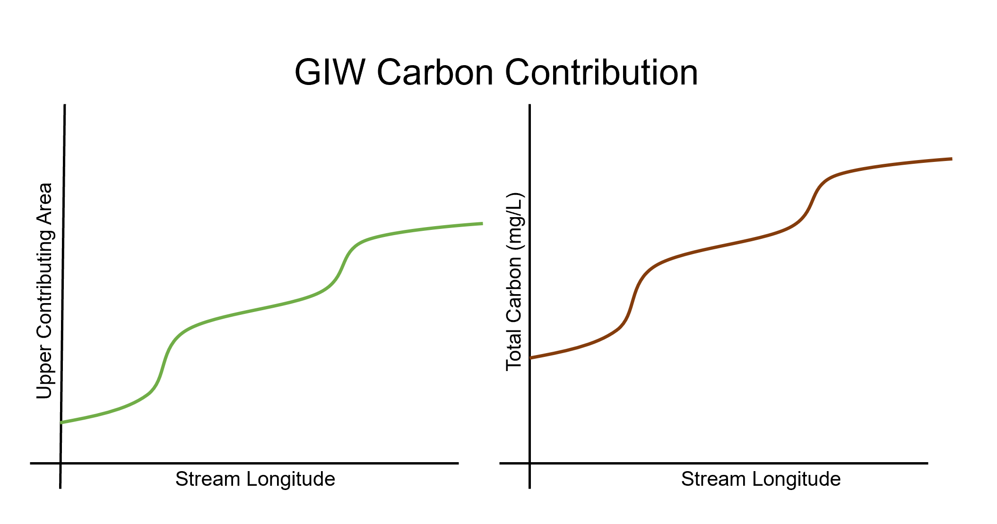
Figure 9: A conceptual figure depicting Hypothesis 1. Due to the inundation of BEF, I expect basins will be transport limited and all streams will gain in carbon as water accumulates downstream.
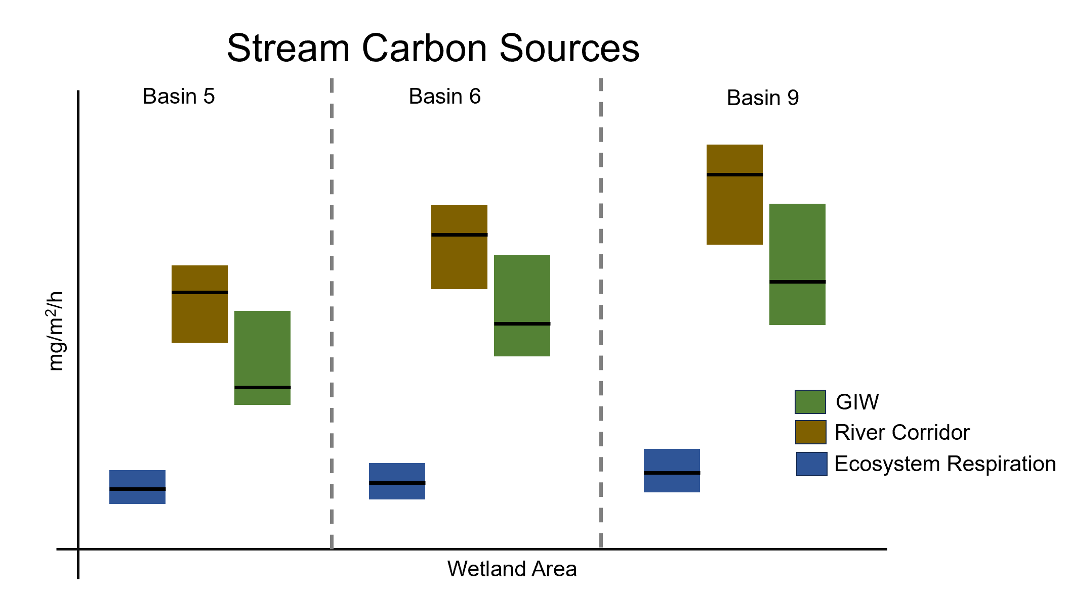
Figure 10: A series of hypothesized boxplots displaying the influence landscape hydrology on stream carbon fluxes. I hypothesize the greater the wetland area, the greater the watershed inundation and the more carbon storage potential. As a result, streams within basins of greater wetland will have more carbon, and subsequently a river corridor and GIWs with more carbon.
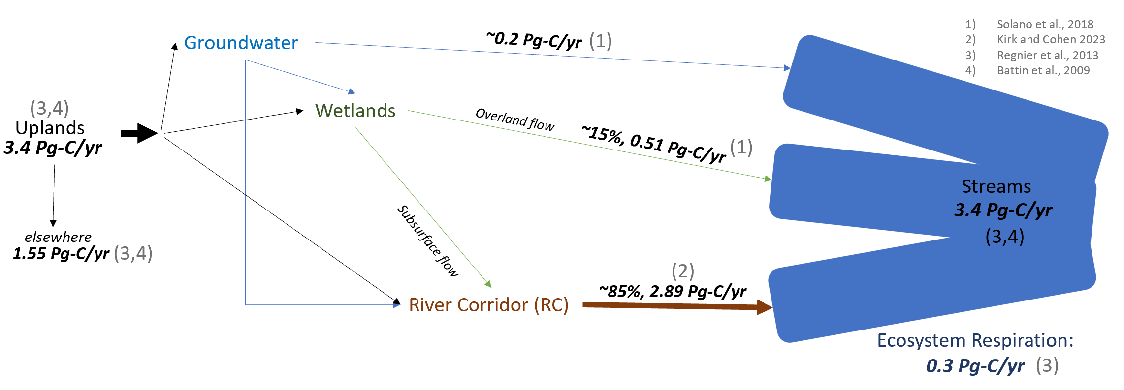
Figure 11: My hypothesized carbon budget for Bradford Experimental Forest (BEF). I predict the river corridor while contributing the majority of stream carbon, reflecting Kirk and Cohen (2020) observations. Assuming groundwater inputs are negligible in confined aquifer units, the remainder is assumed to be sourced from wetland depressions.
Methods:
Sites:
As mentioned, BEF's low-relief terrain fosters a dense cluster of GIWs that support an extensive surficial aquifer (SAq), serving as a transport network between GIWs and streams. For this chapter, I will longitudinally sample streams 5, 6, and 9, which have RC wells from Chapter 2 and high-frequency sensor packages from Chapter 1. Sampling locations will depend on the UCA estimate (see Chapter 2: Methods) and ease of access.
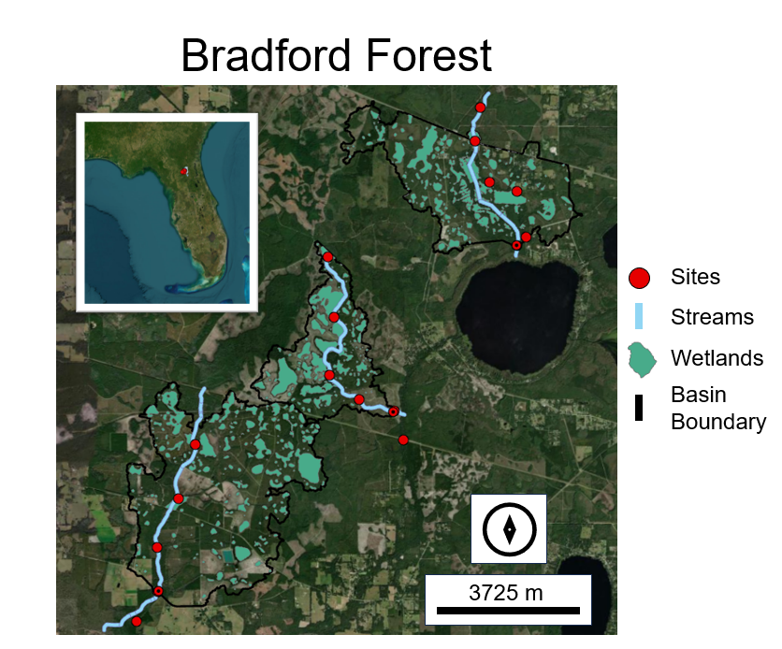
Figure 12: A map of BEF depicting my longitudinal sampling locations. Sampling locations were dependent on access and upper contributing area (UCA). BEF GIWs serve as headwaters for these blackwater streams whether directly or indirectly via overland or subsurface flow.
Sampling and processing:
Streams will be longitudinally sampled during various discharge conditions to encapsulate the hydrologic landscape under changing flow regimes. Each sampling location will be sampled for DOC, DIC, POC, and FDOM. Point-CO₂ measurements will not be recorded due to diurnal fluctuations; instead, high-frequency CO₂ readings from the Chapter 1 sensor package will be used as the assumed reach average. Point-pH and temperature readings will be recorded for potential CO₂ interpolation and quality control.
FDOM, DIC, DOC, and POC processing will follow the methods outlined in Chapter 1. FDOM results from Chapters 1, 2, and 3 will be used to investigate carbon quality changes as it is exported across aquatic boundaries.
Data Analysis and Carbon Budgeting:
Synthesizing my results from Chapters 1 and 2, and assuming RC carbon fluxes have an identical relationship along the entire stream channel, sources of stream carbon will be parsed. Using the UCA analysis conducted in Chapter 2, all carbon samples (DOC, DIC, and POC) and CO₂ observations will be transformed into fluxes. By subtracting RC fluxes from the longitudinal estimates, the remainder is assumed to be sourced from GIWs. The BEF belongs to a confined aquifer unit; therefore, deeper groundwater seepage can be considered negligible.

Timeline:
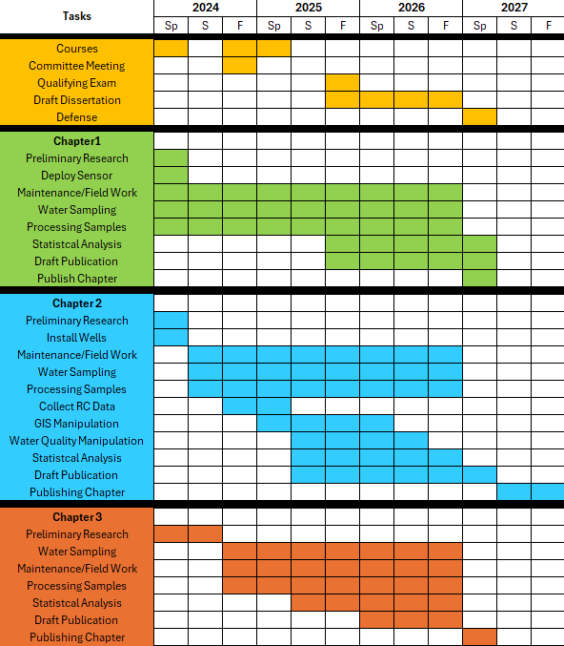

References:
Abril, G., & Borges, A. V. (2019). Ideas and perspectives: Carbon leaks from flooded land: Do we need to replumb the inland water active pipe? Biogeosciences, 16(3), 769–784. https://doi.org/10.5194/bg-16-769-2019
Abril, G., Martinez, J. M., Artigas, L. F., Moreira-Turcq, P., Benedetti, M. F., Vidal, L., Meziane, T., Kim, J. H., Bernardes, M. C., Savoye, N., Deborde, J., Souza, E. L., Albéric, P., Landim De Souza, M. F., & Roland, F. (2014). Amazon River carbon dioxide outgassing fuelled by wetlands. Nature, 505(7483), 395–398. https://doi.org/10.1038/nature12797
Ågren, A., Buffam, I., Jansson, M., & Laudon, H. (2007). Importance of seasonality and small streams for the landscape regulation of dissolved organic carbon export. Journal of Geophysical Research: Biogeosciences, 112(3). https://doi.org/10.1029/2006JG000381
Aufdenkampe, A. K., Mayorga, E., Raymond, P. A., Melack, J. M., Doney, S. C., Alin, S. R., Aalto, R. E., & Yoo, K. (2011). Riverine coupling of biogeochemical cycles between land, oceans, and atmosphere. Frontiers in Ecology and the Environment, 9(1), 53–60. https://doi.org/10.1890/100014
Battin, T. J., Lauerwald, R., Bernhardt, E. S., Bertuzzo, E., Gener, L. G., Hall, R. O., Hotchkiss, E. R., Maavara, T., Pavelsky, T. M., Ran, L., Raymond, P., Rosentreter, J. A., & Regnier, P. (2023). River ecosystem metabolism and carbon biogeochemistry in a changing world. In Nature (Vol. 613, Issue 7944, pp. 449–459). Nature Research. https://doi.org/10.1038/s41586-022-05500-8
Battin, T. J., Luyssaert, S., Kaplan, L. A., Aufdenkampe, A. K., Richter, A., & Tranvik, L. J. (2009). The boundless carbon cycle. In Nature Geoscience (Vol. 2, Issue 9, pp. 598–600). https://doi.org/10.1038/ngeo618
Bernal, S., Cohen, M. J., Ledesma, J. L. J., Kirk, L., Martí, E., & Lupon, A. (2022). Stream metabolism sources a large fraction of carbon dioxide to the atmosphere in two hydrologically contrasting headwater streams. Limnology and Oceanography, 67(12), 2621–2634. https://doi.org/10.1002/lno.12226
Bernhardt, E. S., Rosi, E. J., & Gessner, M. O. (2017). Synthetic chemicals as agents of global change. Frontiers in Ecology and the Environment, 15(2), 84–90. https://doi.org/10.1002/fee.1450
Bertuzzo, E., Hotchkiss, E. R., Argerich, A., Kominoski, J. S., Oviedo-Vargas, D., Savoy, P., Scarlett, R., von Schiller, D., & Heffernan, J. B. (2022). Respiration regimes in rivers: Partitioning source-specific respiration from metabolism time series. Limnology and Oceanography, 67(11), 2374–2388. https://doi.org/10.1002/lno.12207
Casson, N. J., Eimers, M. C., Watmough, S. A., & Richardson, M. C. (2019). The role of wetland coverage within the near-stream zone in predicting of seasonal stream export chemistry from forested headwater catchments. Hydrological Processes, 33(10), 1465–1475. https://doi.org/10.1002/hyp.13413
Cole, J. J., & Caraco, N. F. (2001). Carbon in catchments: Connecting terrestrial carbon losses with aquatic metabolism. Marine and Freshwater Research, 52(1), 101–110. https://doi.org/10.1071/MF00084
Cole, J. J., Prairie, Y. T., Caraco, N. F., McDowell, W. H., Tranvik, L. J., Striegl, R. G., Duarte, C. M., Kortelainen, P., Downing, J. A., Middelburg, J. J., & Melack, J. (2007). Plumbing the global carbon cycle: Integrating inland waters into the terrestrial carbon budget. Ecosystems, 10(1), 171–184. https://doi.org/10.1007/s10021-006-9013-8
Crawford, J. T., Lottig, N. R., Stanley, E. H., Walker, J. F., Hanson, P. C., Finlay, J. C., & Striegl, R. G. (2014). CO2 and CH4 emissions from streams in a lake-rich landscape: Patterns, controls, and regional significance. Global Biogeochemical Cycles, 28(3), 197–210. https://doi.org/10.1002/2013GB004661
Drake, T. W., Raymond, P. A., & Spencer, R. G. M. (2018). Terrestrial carbon inputs to inland waters: A current synthesis of estimates and uncertainty. In Limnology And Oceanography Letters (Vol. 3, Issue 3, pp. 132–142). John Wiley and Sons Inc. https://doi.org/10.1002/lol2.10055
Duvert, C., Bossa, M., Tyler, K. J., Wynn, J. G., Munksgaard, N. C., Bird, M. I., Setterfield, S. A., & Hutley, L. B. (2019). Groundwater-Derived DIC and Carbonate Buffering Enhance Fluvial CO 2 Evasion in Two Australian Tropical Rivers. Journal of Geophysical Research: Biogeosciences, 124(2), 312–327. https://doi.org/10.1029/2018JG004912
Evenson, G. R., Golden, H. E., Lane, C. R., McLaughlin, D. L., & D’Amico, E. (2018). Depressional wetlands affect watershed hydrological, biogeochemical, and ecological functions. Ecological Applications, 28(4), 953–966. https://doi.org/10.1002/eap.1701
Hall, R. O., Tank, J. L., Baker, M. A., Rosi-Marshall, E. J., & Hotchkiss, E. R. (2016). Metabolism, Gas Exchange, and Carbon Spiraling in Rivers. Ecosystems, 19(1), 73–86. https://doi.org/10.1007/s10021-015-9918-1
Hall, R. O., & Ulseth, A. J. (2020). Gas exchange in streams and rivers. In Wiley Interdisciplinary Reviews: Water (Vol. 7, Issue 1). John Wiley and Sons Inc. https://doi.org/10.1002/WAT2.1391
Harvey, J., & Gooseff, M. (2015). River corridor science: Hydrologic exchange and ecological consequences from bedforms to basins. In Water Resources Research (Vol. 51, Issue 9, pp. 6893–6922). Blackwell Publishing Ltd. https://doi.org/10.1002/2015WR017617
Hedin, L. O., Von Fischer, J. C., Ostrom, N. E., Kennedy, B. P., Brown, M. G., & Philip Robertson, G. (1998). Thermodynamic constraints on nitrogen transformations and other biogeochemical processes at soil-stream interfaces. Ecology, 79(2), 684–703. https://doi.org/10.1890/0012-9658(1998)079[0684:TCONAO]2.0.CO;2
Hosen, J. D., Armstrong, A. W., & Palmer, M. A. (2018). Dissolved organic matter variations in coastal plain wetland watersheds: The integrated role of hydrological connectivity, land use, and seasonality. Hydrological Processes, 32(11), 1664–1681. https://doi.org/10.1002/hyp.11519
Hotchkiss, E. R., Hall, R. O., Sponseller, R. A., Butman, D., Klaminder, J., Laudon, H., Rosvall, M., & Karlsson, J. (2015). Sources of and processes controlling CO2emissions change with the size of streams and rivers. Nature Geoscience, 8(9), 696–699. https://doi.org/10.1038/ngeo2507
Kempe, S. (n.d.). Long-term Records of CO2 Pressure Fluctuations in Fresh Waters. https://www.researchgate.net/publication/257029890
Khadka, M. B., Martin, J. B., & Jin, J. (2014). Transport of dissolved carbon and CO2 degassing from a river system in a mixed silicate and carbonate catchment. Journal of Hydrology, 513, 391–402. https://doi.org/10.1016/j.jhydrol.2014.03.070
Kirk, L., & Cohen, M. J. (2023). River Corridor Sources Dominate CO2 Emissions From a Lowland River Network. Journal of Geophysical Research: Biogeosciences, 128(1). https://doi.org/10.1029/2022JG006954
Lauerwald, R., Hartmann, J., Ludwig, W., & Moosdorf, N. (2012). Assessing the nonconservative fluvial fluxes of dissolved organic carbon in North America. Journal of Geophysical Research: Biogeosciences, 117(1). https://doi.org/10.1029/2011JG001820
Ledesma, J. L. J., Grabs, T., Bishop, K. H., Schiff, S. L., & Köhler, S. J. (2015). Potential for long-term transfer of dissolved organic carbon from riparian zones to streams in boreal catchments. Global Change Biology, 21(8), 2963–2979. https://doi.org/10.1111/gcb.12872
Ledesma, J. L. J., Kothawala, D. N., Bastviken, P., Maehder, S., Grabs, T., & Futter, M. N. (2018). Stream Dissolved Organic Matter Composition Reflects the Riparian Zone, Not Upslope Soils in Boreal Forest Headwaters. Water Resources Research, 54(6), 3896–3912. https://doi.org/10.1029/2017WR021793
Leibowitz, S. G., Wigington, P. J., Schofield, K. A., Alexander, L. C., Vanderhoof, M. K., & Golden, H. E. (2018a). Connectivity of Streams and Wetlands to Downstream Waters: An Integrated Systems Framework. Journal of the American Water Resources Association, 54(2), 298–322. https://doi.org/10.1111/1752-1688.12631
Leibowitz, S. G., Wigington, P. J., Schofield, K. A., Alexander, L. C., Vanderhoof, M. K., & Golden, H. E. (2018b). Connectivity of Streams and Wetlands to Downstream Waters: An Integrated Systems Framework. Journal of the American Water Resources Association, 54(2), 298–322. https://doi.org/10.1111/1752-1688.12631
Liu, S., Kuhn, C., Amatulli, G., Aho, K., Butman, D. E., Allen, G. H., Lin, P., Pan, M., Yamazaki, D., Brinkerhoff, C., Gleason, C., Xia, X., & Raymond, P. A. (2022). The importance of hydrology in routing terrestrial carbon to the atmosphere via global streams and rivers. https://doi.org/10.1073/pnas.2106322119/-/DCSupplemental
Lupon, A., Denfeld, B. A., Laudon, H., Leach, J., Karlsson, J., & Sponseller, R. A. (2019). Groundwater inflows control patterns and sources of greenhouse gas emissions from streams. Limnology and Oceanography, 64(4), 1545–1557. https://doi.org/10.1002/lno.11134
Marton, J. M., Creed, I. F., Lewis, D. B., Lane, C. R., Basu, N. B., Cohen, M. J., & Craft, C. B. (2015). Geographically isolated wetlands are important biogeochemical reactors on the landscape. In BioScience (Vol. 65, Issue 4, pp. 408–418). Oxford University Press. https://doi.org/10.1093/biosci/biv009
Marx, A., Dusek, J., Jankovec, J., Sanda, M., Vogel, T., van Geldern, R., Hartmann, J., & Barth, J. A. C. (2017). A review of CO2 and associated carbon dynamics in headwater streams: A global perspective. Reviews of Geophysics, 55(2), 560–585. https://doi.org/10.1002/2016RG000547
McDowell, M. J., & Johnson, M. S. (2018). Gas Transfer Velocities Evaluated Using Carbon Dioxide as a Tracer Show High Streamflow to Be a Major Driver of Total CO2 Evasion Flux for a Headwater Stream. Journal of Geophysical Research: Biogeosciences, 123(7), 2183–2197. https://doi.org/10.1029/2018JG004388
McLaughlin, D. L., Kaplan, D. A., & Cohen, M. J. (2014). A significant nexus: Geographically isolated wetlands influence landscape hydrology. Water Resources Research, 50(9), 7153–7166. https://doi.org/10.1002/2013WR015002
Mitsch, W. J., Bernal, B., Nahlik, A. M., Mander, Ü., Zhang, L., Anderson, C. J., Jørgensen, S. E., & Brix, H. (2013). Wetlands, carbon, and climate change. Landscape Ecology, 28(4), 583–597. https://doi.org/10.1007/s10980-012-9758-8
Raymond, P. A., Hartmann, J., Lauerwald, R., Sobek, S., McDonald, C., Hoover, M., Butman, D., Striegl, R., Mayorga, E., Humborg, C., Kortelainen, P., Dürr, H., Meybeck, M., Ciais, P., & Guth, P. (2013). Global carbon dioxide emissions from inland waters. Nature, 503(7476), 355–359. https://doi.org/10.1038/nature12760
Raymond, P. A., Saiers, J. E., & Sobczak, W. V. (2016). Hydrological and biogeochemical controls on watershed dissolved organic matter transport: Pulse- shunt concept. Ecology, 97(1), 5–16. https://doi.org/10.1890/14-1684.1
Regnier, P., Friedlingstein, P., Ciais, P., Mackenzie, F. T., Gruber, N., Janssens, I. A., Laruelle, G. G., Lauerwald, R., Luyssaert, S., Andersson, A. J., Arndt, S., Arnosti, C., Borges, A. V., Dale, A. W., Gallego-Sala, A., Goddéris, Y., Goossens, N., Hartmann, J., Heinze, C., … Thullner, M. (2013). Anthropogenic perturbation of the carbon fluxes from land to ocean. Nature Geoscience, 6(8), 597–607. https://doi.org/10.1038/ngeo1830
Regnier, P., Resplandy, L., Najjar, R. G., & Ciais, P. (2022). The land-to-ocean loops of the global carbon cycle. In Nature (Vol. 603, Issue 7901, pp. 401–410). Nature Research. https://doi.org/10.1038/s41586-021-04339-9
Saunois, M., Bousquet, P., Poulter, B., Peregon, A., Ciais, P., Canadell, J. G., Dlugokencky, E. J., Etiope, G., Bastviken, D., Houweling, S., Janssens-Maenhout, G., Tubiello, F. N., Castaldi, S., Jackson, R. B., Alexe, M., Arora, V. K., Beerling, D. J., Bergamaschi, P., Blake, D. R., … Zhu, Q. (2016). The global methane budget 2000-2012. Earth System Science Data, 8(2), 697–751. https://doi.org/10.5194/essd-8-697-2016
Solano, V., Duvert, C., Hutley, L. B., Cendón, D. I., Maher, D. T., & Birkel, C. (2024). Seasonal Wetlands Make a Relatively Limited Contribution to the Dissolved Carbon Pool of a Lowland Headwater Tropical Stream. Journal of Geophysical Research: Biogeosciences, 129(2). https://doi.org/10.1029/2023JG007556
Vidon, P., Allan, C., Burns, D., Duval, T. P., Gurwick, N., Inamdar, S., Lowrance, R., Okay, J., Scott, D., & Sebestyen, S. (2010). Hot spots and hot moments in riparian zones: Potential for improved water quality management. Journal of the American Water Resources Association, 46(2), 278–298. https://doi.org/10.1111/j.1752-1688.2010.00420.x
Wilcock, R. J., Champion, P. D., Nagels, J. W., & Croker, G. F. (1999). The influence of aquatic macrophytes on the hydraulic and physico-chemical properties of a New Zealand lowland stream. In Hydrobiologia (Vol. 416).
Winter, T. C. (n.d.). A Conceptual Framework For Assessing Cumulative Impacts on the Hydrology of Nontidal Wetlands. In Environmental Management (Vol. 12, Issue 5).
Zarnetske, J. P., Bouda, M., Abbott, B. W., Saiers, J., & Raymond, P. A. (2018). Generality of Hydrologic Transport Limitation of Watershed Organic Carbon Flux Across Ecoregions of the United States. Geophysical Research Letters, 45(21), 11,702-11,711. https://doi.org/10.1029/2018GL080005

